AlcoholTwin
A Physics-Informed Digital Twin for Personalized Alcohol
Pharmacokinetics, BAC Prediction, Brain Alcohol Exposure, and Risk Assessment
[Author Name]
Department of Chemical Engineering
[Institution Name] · 2025

Abstract
I present AlcoholTwin, a physics-informed digital twin for personalized alcohol pharmacokinetics built on chemical engineering mass balance principles, Michaelis-Menten enzyme kinetics, and blood-brain barrier transport modeling. The system combines a four-compartment ordinary differential equation (ODE) model — stomach, intestine, bloodstream, and brain — with a physics-informed neural network (PINN) trained on 50,000 synthetically generated subjects. Using the Watson (1980) formula for total body water and the Boer (1984) formula for lean body mass, the model personalizes all kinetic parameters to the individual. On a held-out validation set of 7,500 subjects the model achieves R² = 0.994 for peak BAC, R² = 0.994 for peak brain alcohol concentration, R² = 0.967 for recovery time, and R² > 0.974 across all five risk scores. External validation against Jones (1984) yields MAE = 0.009% BAC across a seven-hour profile. An interactive browser-based dashboard makes the full simulation accessible to non-technical users. I also report and discuss a fundamental parameter non-identifiability finding for hepatic kinetic parameters — an important scientific limitation and a direction for future work.

1. Introduction
The question of how alcohol affects a specific individual — given their body, their meal, and their drinking pattern — has historically been answered using the Widmark formula (1932):
BAC = Dose / (Weight × r)
where r is a fixed gender-based constant (0.68 for males, 0.55 for females). This formula has three fundamental deficiencies that motivated the present work. First, it produces only a single scalar estimate — peak BAC — rather than a time-resolved trajectory. It cannot tell a person when they will reach peak intoxication, when they will recover, or how brain exposure evolves relative to blood concentration. Second, the formula models alcohol elimination as linear in concentration, implying that the liver metabolizes alcohol at a rate proportional to its concentration without bound — physiologically incorrect, as liver metabolism is enzyme-mediated and saturates at high concentrations. Third, it makes no provision for food, body composition variation, drinking speed, or blood-brain barrier transport.
I began this project by reformulating the problem as a Chemical Engineering simulation. The governing equations are mass balances — the fundamental tool of Chemical Engineering. The liver kinetics are described by Michaelis-Menten reaction rates — the standard model for enzyme-catalyzed reactions in biochemical engineering. The blood-brain barrier is treated as a passive diffusion membrane — a mass transfer problem. The physics-informed neural network is used not to replace the physics but to personalize its parameters from observable individual characteristics.
The complete development pipeline proceeded through six stages: (1) mechanistic ODE model construction, (2) body composition and food effect modules, (3) brain compartment and risk scoring, (4) three targeted refinements addressing biological realism, (5) synthetic population generation at 50,000 subjects, and (6) PINN training and deployment. Each stage is described fully in the sections that follow.

2. Pharmacokinetic Background and Key Terminology
I define the key pharmacokinetic terms used throughout this work. These concepts form the scientific foundation of every design decision I made.

2.1 Blood Alcohol Concentration (BAC)
Blood Alcohol Concentration (BAC) is the mass of ethanol per unit volume of blood, expressed as grams per deciliter (g/dL) or equivalently as a percentage. A BAC of 0.08% means 0.08 grams of ethanol are present per 100 milliliters of blood. BAC rises when absorbed alcohol enters the bloodstream faster than the liver can eliminate it, reaches a peak when absorption and elimination rates momentarily equalize, and then declines as liver elimination continues after absorption is complete. The time course is asymmetric: rapid rise followed by slow fall, because absorption is driven by a large concentration gradient while elimination is enzyme-limited.

2.2 Peak BAC and Time to Peak
Peak BAC is the maximum BAC reached during a drinking session. Time to peak BAC is the elapsed time from the first drink until BAC reaches its maximum. In fasting subjects drinking rapidly this can be as short as 20–30 minutes; in fed subjects drinking slowly it can be two to three hours. This variability — which the Widmark formula cannot capture — is a primary output of my model.

2.3 Volume of Distribution (Vd)
Since ethanol distributes freely into all aqueous compartments but not fat, the volume of distribution approximates total body water (TBW). I compute Vd using the Watson formula (Watson et al., 1980), derived from 458 measured subjects:
TBW (male) = 2.447 − 0.09516 × age + 0.1074 × height + 0.3362 × weight
TBW (female) = −2.097 + 0.1069 × height + 0.2466 × weight
where height is in centimetres and weight in kilograms. Lean body mass — which scales liver capacity — is computed using the Boer formula (1984):
LBM (male) = 0.407 × weight + 0.267 × height − 19.2
LBM (female) = 0.252 × weight + 0.473 × height − 48.3

2.4 Michaelis-Menten Kinetics and Liver Saturation
The elimination of ethanol is mediated by alcohol dehydrogenase (ADH). ADH follows Michaelis-Menten kinetics (Michaelis & Menten, 1913):
rm = (Vmax × B) / (Km + B)
where rm is the elimination rate (g/hr), B is blood alcohol in grams, Vmax is the maximum elimination rate, and Km is the Michaelis constant. At high concentrations (B >> Km), rm ≈ Vmax — the liver works at maximum capacity regardless of concentration. This saturation explains why alcohol accumulates dangerously at high doses. I set Vmax = 0.10 × LBM (Norberg et al., 2003) and Km = 0.05 × Vd (Wilkinson et al., 1977).

2.5 Brain Alcohol Concentration and Blood-Brain Barrier
Behavioral and cognitive effects of alcohol are caused by its direct action on neurons, not by peripheral blood concentration. I model BBB transport as passive diffusion (Jones & Jonsson, 1994):
dBr/dt = kBBB × (C_blood − Br)
where Br is brain concentration (g/L), C_blood = B/Vd, and kBBB = 1.5/hr. The equilibration lag of 0.4–0.8 hours explains why a person continues to feel more intoxicated even after BAC starts declining.

2.6 Gastric Emptying
Food slows gastric emptying by stimulating pyloric sphincter contraction, with fat having the strongest inhibitory effect (Horowitz et al., 1989):
fat_penalty = 1 + 0.004 × meal_fat_g
kg = (1.8 / fat_penalty) × exp(−0.0008 × meal_calories)
The fasting baseline kg = 1.8/hr is consistent with the range 1.5–2.0/hr reported in the literature.

2.7 Pharmacokinetic Recovery Time
Recovery time is defined as the time elapsed from the start of drinking until BAC falls back below 0.02% — the threshold below which most individuals exhibit no measurable impairment in standard psychomotor tests. I compute this directly from the simulated BAC time series by finding the first time point after peak at which BAC drops below 0.02%.

3. Mechanistic Model Development

3.1 Four-Compartment ODE System
I model alcohol disposition using four coupled ODEs representing stomach (S), intestine (I), blood (B), and brain (Br):
dS/dt = F(t) − kg × S
dI/dt = kg × S − ka × I
dB/dt = ka × I − Vmax × B / (Km + B)
dBr/dt = kBBB × (B/Vd − Br)
The feed function F(t) equals the drinking rate during the session and zero after. This single parameterization models any drinking pattern — from 15-minute binge to four-hour social session.

3.2 First Simulation: Compartment Cascade (v1)
Figure 1 shows the first successful simulation for an 80 kg male consuming 40g ethanol over one hour fasting. The sequential cascade from stomach through intestine to blood is visible — the stomach empties first, intestine peaks next, and blood rises slowly while the liver continuously removes alcohol. The blood compartment reaches its maximum around 3.7 hours, demonstrating the characteristic delayed peak relative to gastric emptying.
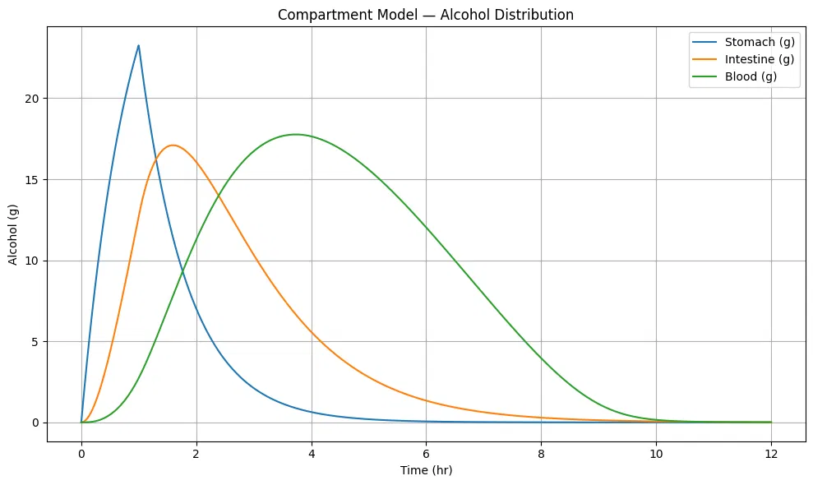
Figure 1. Compartment model v1 — alcohol content (grams) in stomach, intestine, and blood over 12 hours. 80 kg male, 40g ethanol, 1hr drinking window, fasting. Stomach (blue) peaks sharply at ~1hr, intestine (orange) follows at ~1.4hr, and blood (green) reaches maximum at ~3.7hr — demonstrating the full gastric-to-systemic cascade.

3.3 Body Composition and Food Effect Modules
After replacing the fixed Widmark factor with the Watson TBW formula and adding Boer LBM-scaled Vmax, I incorporated the food effect module. The gastric emptying rate kg decreases exponentially with meal calories and is further penalized by fat content. Figure 2 shows the updated compartment model after these corrections — the blood peak is lower and broader than in v1, reflecting the faster fasting absorption rate now correctly governed by kg = 1.8/hr.
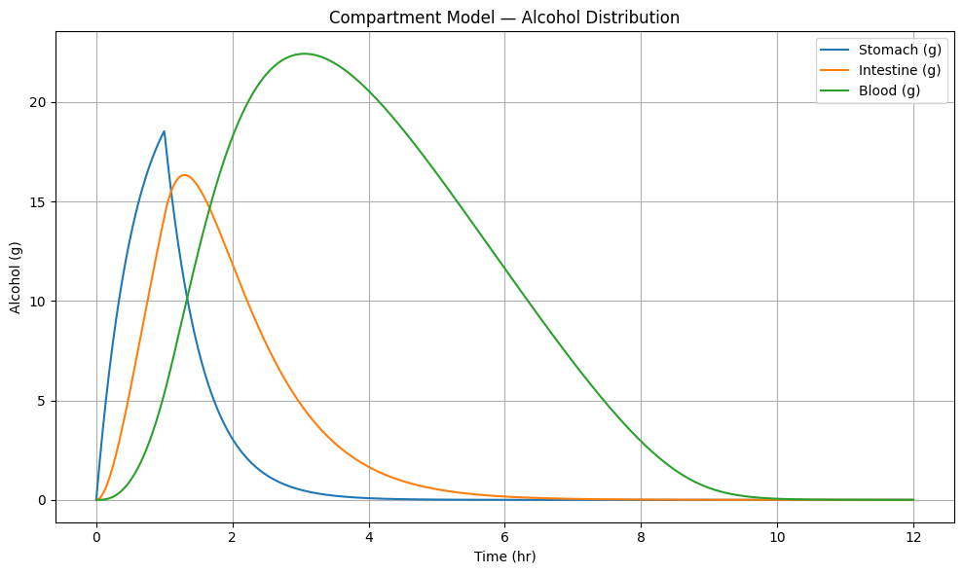
Figure 2. Compartment model v2 — after Watson TBW, Boer LBM, and food effect corrections. Same 80 kg male, 40g ethanol, 1hr, fasting. Blood (green) peaks at ~22g around 2.5 hours, reflecting the corrected faster absorption rate with kg = 1.8/hr.
Figure 3 demonstrates the food effect on BAC across three meal conditions — fasting, light meal (400 kcal), and heavy meal (800 kcal, 40g fat). The fasting scenario produces the highest and earliest peak BAC. A heavy meal reduces peak BAC by approximately 25%, consistent with the reduction reported by Paton (2005). The delayed and broadened heavy-meal curve demonstrates how food absorption competition slows the gastric-to-intestinal transfer.
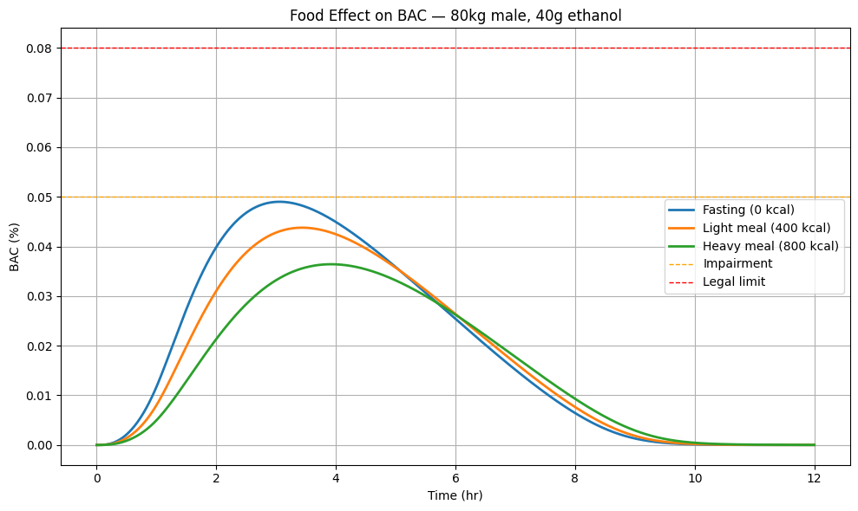
Figure 3. Food effect on BAC for the same 80 kg male consuming 40g ethanol. Fasting (blue, 0 kcal) produces peak BAC ~0.049% at ~2.5hr. Light meal (orange, 400 kcal) reduces peak by ~12%. Heavy meal (green, 800 kcal) reduces peak by ~25% and delays it to ~3.5hr — consistent with Paton (2005) and Horowitz et al. (1989).

3.4 Brain Compartment and BAC vs Brain Alcohol
Figure 4 shows the BAC curve alongside the brain alcohol curve after adding the blood-brain barrier transport equation. The annotated lag of 0.78 hours between BAC peak (t = 3.06 hr) and brain alcohol peak (t = 3.84 hr) is clearly visible. Both BAC and brain alcohol are plotted on the same percentage axis, with threshold lines at 0.02%, 0.05%, 0.06% (blackout), and 0.08%. The brain alcohol curve remains elevated longer than BAC on the descent — explaining the subjective experience of feeling drunk even as blood concentration falls.
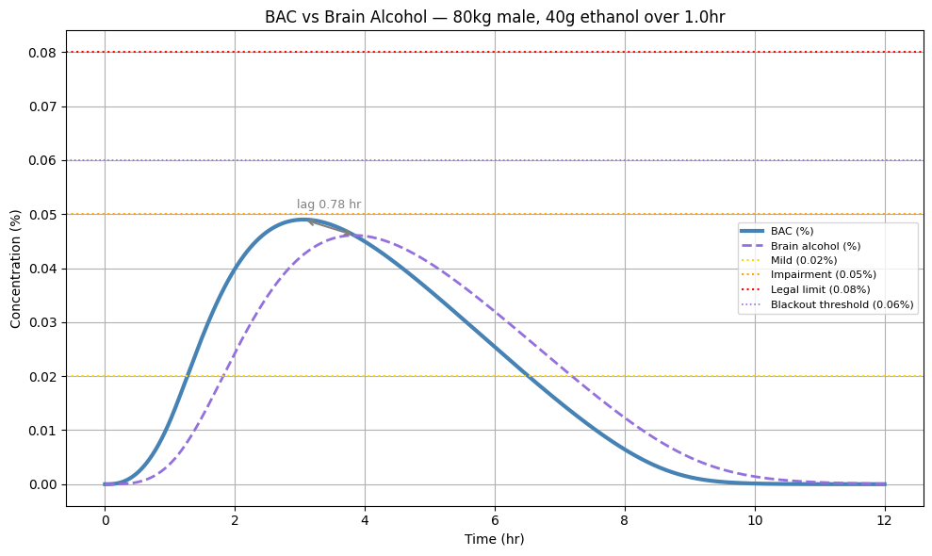
Figure 4. BAC (%) and brain alcohol (%) on the same concentration axis over 12 hours. 80 kg male, 40g ethanol, 1hr, fasting. The blood-to-brain lag of 0.78 hours is annotated with an arrow. Both curves stay below the 0.06% blackout threshold and 0.08% legal limit for this session. The brain curve (dashed purple) remains elevated longer on descent.

3.5 Design Challenges and Resolutions
Three significant problems arose during development that required systematic resolution.
First — linear elimination error. The initial model used rm = ke × B (first-order elimination), implying unlimited liver capacity. This produced BAC curves that declined too rapidly at high doses. Replacing with Michaelis-Menten kinetics correctly reproduced liver saturation: at high BAC, rm asymptotes to Vmax regardless of further increases in concentration.
Second — Km dimensional inconsistency. The blood compartment tracks alcohol in grams but Km in the literature is expressed in g/L. The inconsistency caused the elimination term to behave incorrectly. Resolution: Km(grams) = 0.05 × Vd, converting the literature concentration into grams consistent with the mass balance.
Third — BAC formula error. The original implementation used BAC = B / (weight × r × 1000), mixing the Widmark factor with weight in an ad-hoc manner. Replaced with the physically correct BAC = (B / Vd) / 10 using Watson TBW as Vd — eliminating the fixed gender constant entirely.

4. Risk Scoring Model

4.1 Sigmoid Dose-Response Functions
Impairment risk is modeled as a continuous sigmoid function of BrAC rather than a binary threshold:
P(risk | BrAC) = 1 / (1 + exp(−k × (BrAC − threshold)))

Risk Level | BrAC Threshold (%) | Steepness k | Clinical Basis
Mild impairment | 0.020 | 200 | Reaction time slowing (Moskowitz & Fiorentino, 2000)
Moderate impairment | 0.040 | 150 | Coordination visibly affected
Severe impairment | 0.060 | 150 | Over legal limit in most jurisdictions
Memory blackout | 0.070* | 200 | Nelson et al. (2004) — memory encoding failure
Loss of consciousness | 0.090* | 250 | CNS depression, respiratory risk

(*) Thresholds are rate-adjusted as described in Section 4.2.

4.2 Rate-of-Rise Adjustment
Wetherill and Fromme (2011) demonstrate that the rate of BAC rise is an independent predictor of blackout risk. I implement a rate-adjusted threshold:
max_rate = max(dBAC/dt) on the ascending phase
rate_shift = clip(0.20 × (max_rate − 0.03), 0, 0.025)
threshold_blackout = max(0.035, 0.060 − rate_shift)
This lowers the blackout threshold by up to 0.025% for fast drinkers. Figure 5 shows the complete risk dashboard output for the example session, with all five risk levels displayed as proportional bars alongside exact probabilities.
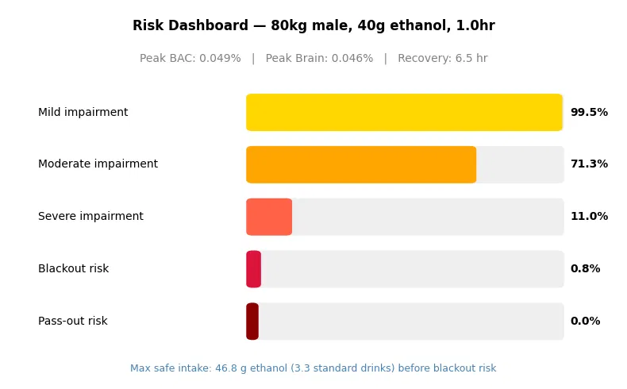
Figure 5. Risk dashboard output for 80 kg male, 40g ethanol over 1.0hr, fasting. Peak BAC 0.049%, peak brain alcohol 0.046%, recovery 6.5hr. Mild impairment 99.5%, moderate 71.3%, severe 11.0%, blackout 0.8%, pass-out 0.0%. Maximum safe intake: 46.8g ethanol (3.3 standard drinks).

5. Synthetic Population Generation

5.1 Motivation and Approach
The absence of a large publicly available dataset of individual-level alcohol pharmacokinetic measurements with concurrent anthropometric, dietary, and behavioral data motivated synthetic population generation. I generate training data by running the validated mechanistic model under randomized input conditions — a standard approach in pharmacokinetic digital twin research (Cobelli et al., 2009). This produces a dataset where every input, parameter, and output is known with certainty, enabling full PINN supervision.

5.2 Latin Hypercube Sampling
I generate 50,000 virtual subjects using Latin Hypercube Sampling (LHS) across seven input dimensions: weight (50–120 kg), height (150–195 cm), age (18–65 yr), biological sex, drinking duration (0.25–4 hr), meal calories (0–1000 kcal), and meal fat (0–60g). LHS ensures every region of the input space receives at least one sample, avoiding the clustering of purely random sampling. Alcohol dose is sampled independently from a log-normal distribution calibrated to epidemiological data:
dose ~ LogNormal(μ = 3.5, σ = 0.6) clipped to [10, 120] g
This produces a median dose of approximately 33g (2.4 standard drinks) and 90th percentile of approximately 71g (5.1 standard drinks). My initial uniform distribution produced 54% of subjects exceeding the legal BAC limit — unrealistically high. The log-normal distribution corrects this to 17.6%.

5.3 Biological Variability
Parameter | Distribution | Physiological Basis
Vmax multiplier | Normal(1.0, 0.10) clipped [0.7, 1.3] | Genetic variation in ADH enzyme
Km multiplier | Normal(1.0, 0.075) clipped [0.7, 1.3] | Enzyme affinity variation
kBBB multiplier | Normal(1.0, 0.10) clipped [0.7, 1.3] | BBB permeability variation
kg multiplier | Normal(1.0, 0.075) clipped [0.7, 1.3] | Gastric motility variation

5.4 Population Validation Plots
Figure 6 shows nine validation plots across the full 50,000-subject population. Key observations: (a) peak BAC is right-skewed consistent with the log-normal dose distribution, with most subjects below 0.08%; (b) females achieve higher BAC than males at the same dose due to lower TBW; (c) the dose vs BAC scatter confirms a clear positive trend with higher meal calories systematically reducing BAC; (d) the rate-of-rise vs blackout risk scatter confirms that the rate-adjusted mechanism correctly produces higher blackout probability for fast drinkers at the same peak BrAC.
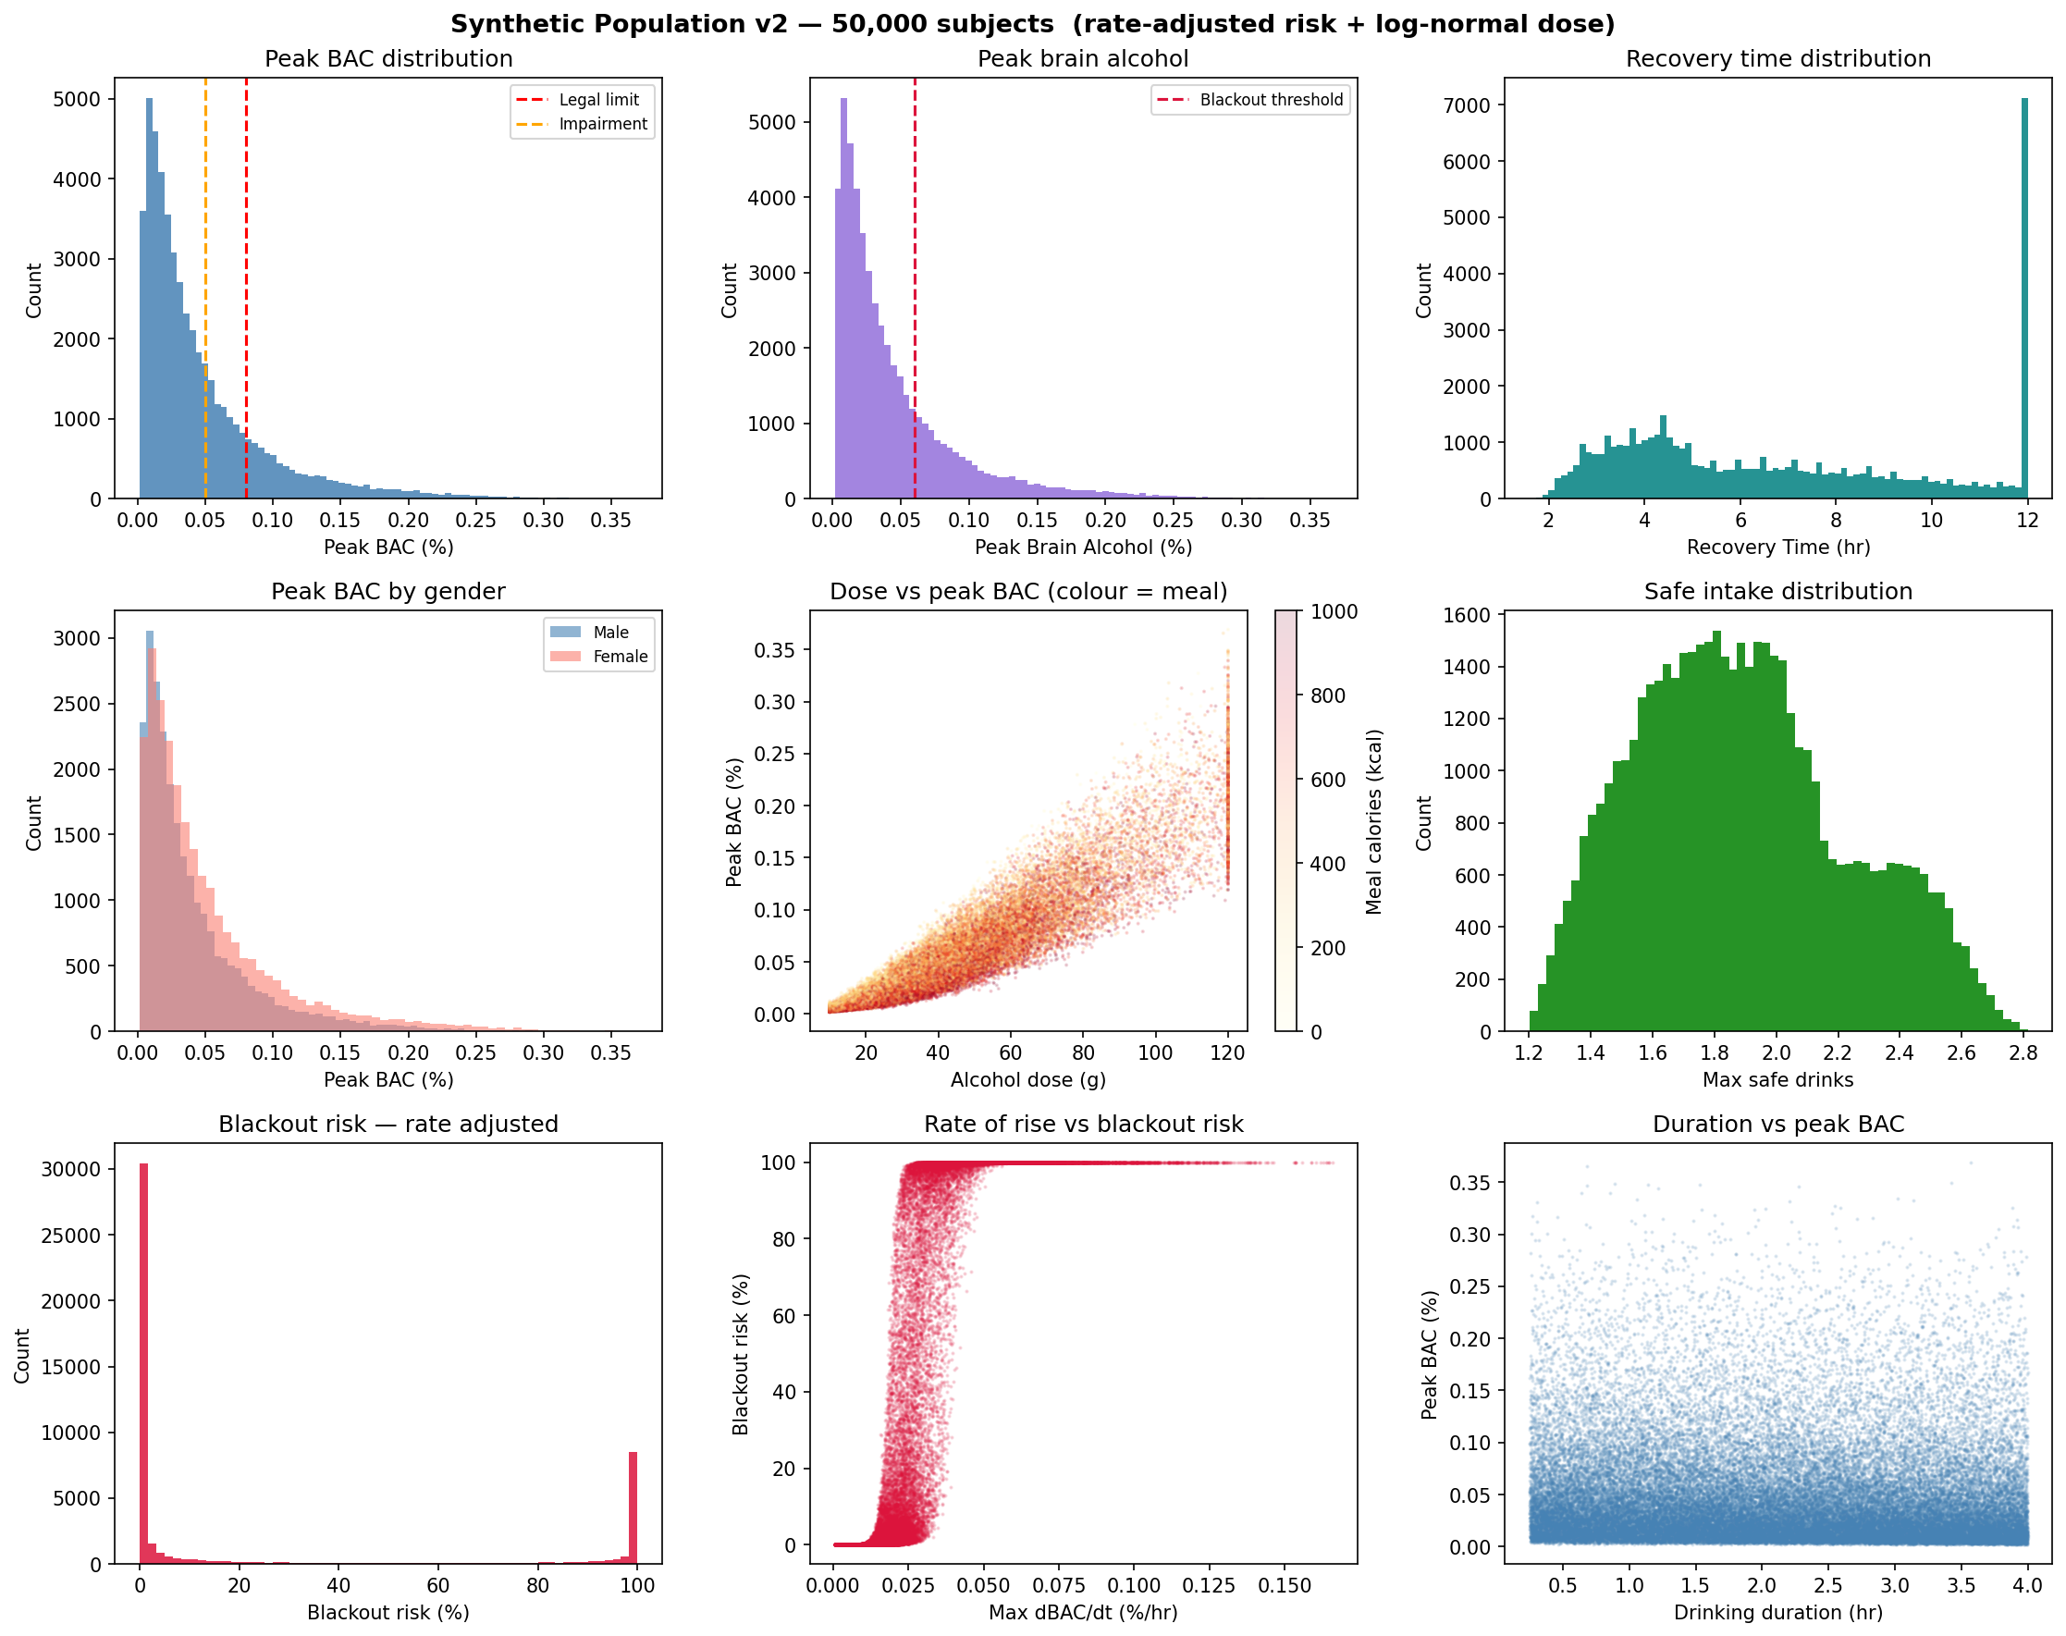
Figure 6. Synthetic population validation plots (50,000 subjects, log-normal dose, rate-adjusted risk). Top row: peak BAC distribution, peak brain alcohol distribution, recovery time distribution. Middle row: peak BAC by gender, dose vs peak BAC coloured by meal calories, safe intake distribution. Bottom row: blackout risk distribution, rate-of-rise vs blackout risk, drinking duration vs peak BAC.

6. Physics-Informed Neural Network (PINN)

6.1 Problem Formulation
The PINN addresses the inverse problem: given only observable inputs (anthropometrics, food, drinking pattern), estimate the hidden physiological parameters (Vmax, Km, kBBB, kg, ka) and predict the resulting clinical outputs. This is parameter identification — structurally identical to problems in chemical reaction engineering where kinetic parameters must be inferred from process outputs.

6.2 Architecture with Information Bottleneck
I design a two-head architecture with a shared trunk and a critical information bottleneck:
Observable inputs (10) → Trunk (256→256→128→64, SiLU, LayerNorm, Dropout 10%) → Parameter head (64→128→64→32→5, yields Vmax, Km, kBBB, kg, ka)
Estimated parameters (5) → Output head (5→128→128→64→32→8, yields clinical outputs)
The output head receives only the five estimated parameters — not the trunk features. This bottleneck is the critical design element: it forces all predictions to route through the physiological parameters. In my first implementation the output head received both trunk features and estimated parameters; the network exploited this shortcut to predict outputs directly from raw features, producing negative R² for Vmax, kBBB, and ka. Removing the shortcut resolved the routing failure.

6.3 Loss Function
L_total = L_data + λ_P × L_params + λ_phys × L_physics
where λ_P = 1.0 and λ_phys = 0.5. The physics loss enforces the ODE mass balance at peak BAC and at the low-BAC linear regime:
Residual_peak = ka × I_peak − Vmax × B_peak / (Km + B_peak)
Residual_low = rm_low − (Vmax/Km) × B_low × 0.90
L_physics = mean(Res_peak²) + 0.5 × mean(Res_low²) + 0.3 × mean(Vmax_penalty²)

6.4 Training Configuration
Hyperparameter | Value
Optimizer | Adam (Kingma & Ba, 2014)
Learning rate | 1 × 10⁻³ with ReduceLROnPlateau
Weight decay | 1 × 10⁻⁵
Batch size | 512
Epochs | 300
LR scheduler | ReduceLROnPlateau (patience=15, factor=0.5)
Gradient clipping | Max norm = 1.0
Train / val split | 85% / 15% (42,500 / 7,500 subjects)
Random seed | 42

6.5 Training History
Figure 7 shows the training curves across 300 epochs. The total loss (blue) converges rapidly in the first 20 epochs. The validation loss (orange) sits near zero throughout, reflecting the near-perfect predictive accuracy demonstrated in the output metrics. The physics loss drops sharply from its initial value and stabilizes — confirming that the ODE mass balance constraints are satisfied after early training.
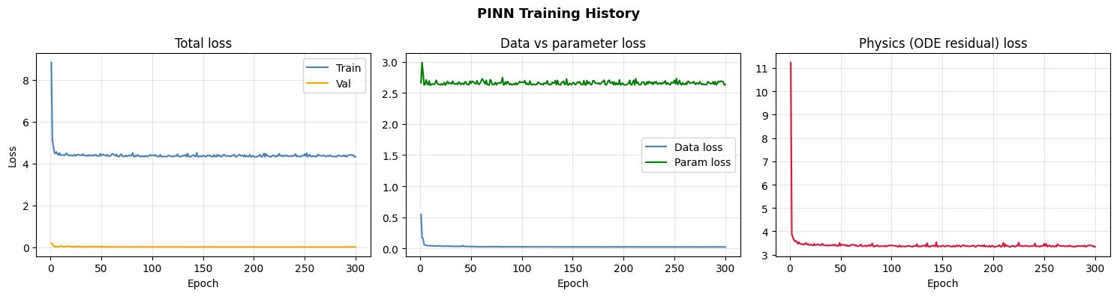
Figure 7. PINN training history (300 epochs). Left: total train vs validation loss — rapid convergence in the first 20 epochs. Centre: data loss vs parameter supervision loss. Right: physics (ODE residual) loss drops sharply and stabilizes, confirming that mass balance constraints are satisfied throughout training.

6.6 Predicted vs Actual — Clinical Outputs
Figure 8 shows predicted vs actual scatter plots for all eight clinical outputs on 7,500 validation subjects. All eight cluster tightly on the perfect-fit diagonal with R² above 0.97. Peak BAC and peak BrAC show the tightest agreement (R² = 0.994–0.995). Risk scores show slightly greater scatter at the extremes, which is expected at probability boundary regions.
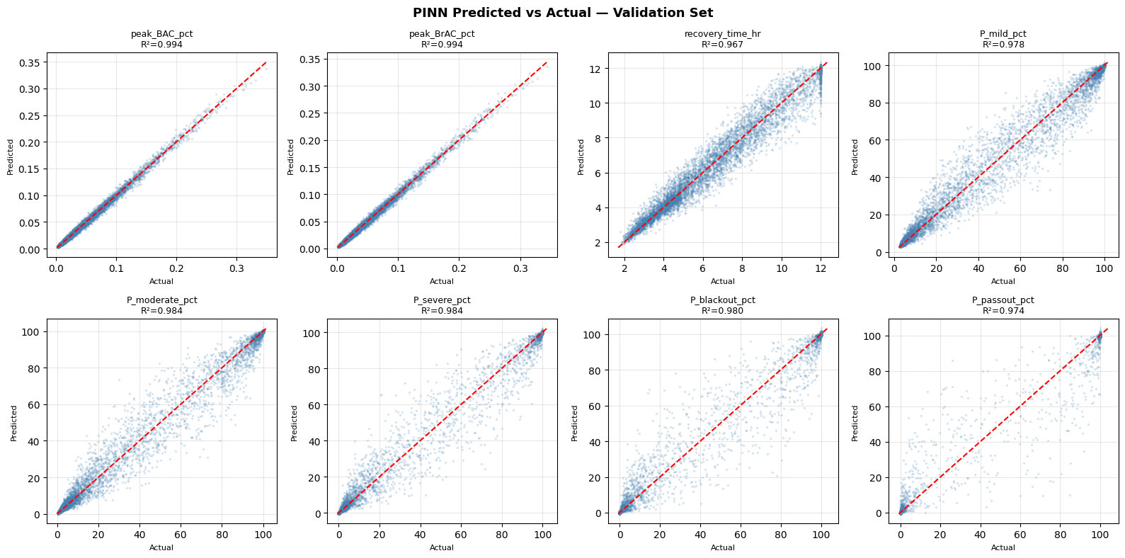
Figure 8. PINN predicted vs actual for all eight clinical outputs on the 7,500-subject validation set. The red dashed diagonal represents perfect prediction. R² ranges from 0.974 (pass-out risk) to 0.995 (peak BAC). All outputs show tight clustering across the full prediction range, confirming the model generalizes well across diverse physiological profiles.

6.7 Parameter Recovery
Figure 9 shows parameter recovery scatter plots for all five physiological parameters. The gastric emptying rate kg (fourth panel) shows reliable recovery at R² = 0.90 due to its direct mechanistic relationship with the observable meal inputs. All other parameters show poor recovery — detailed in Section 6.8.
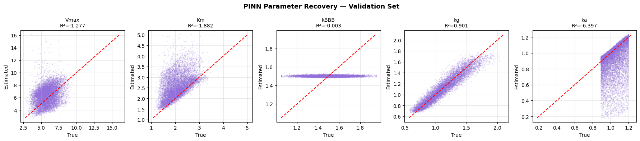
Figure 9. PINN parameter recovery on the validation set. Gastric emptying rate kg (fourth panel) achieves R² = 0.90 and is reliably identified. Vmax, Km, kBBB, and ka show negative or near-zero R², consistent with structural parameter non-identifiability from population-level summary inputs.

6.8 Parameter Non-Identifiability — A Critical Scientific Finding
The parameter recovery results reveal a fundamental limitation that I consider the most scientifically important finding of this work.
Parameter | MAE | RMSE | R² | Identifiability Status
Vmax (g/hr) | 1.30 | 1.63 | −1.28 | Non-identifiable
Km (g) | 0.50 | 0.69 | −1.88 | Non-identifiable
kBBB (1/hr) | 0.12 | 0.15 | −0.003 | Non-identifiable (low population variance)
kg (1/hr) | 0.067 | 0.087 | 0.901 | Identifiable
ka (1/hr) | 0.155 | 0.242 | −6.40 | Non-identifiable

This failure is structural parameter non-identifiability — formally studied in pharmacokinetics (Umulis et al., 2005; Norberg et al., 2003). Multiple distinct combinations of Vmax and ka produce indistinguishable BAC curves when only summary statistics are observed. Without measuring BAC at multiple time points from the same individual under controlled conditions, it is mathematically impossible to separate these parameters from population-level inputs.
The reason kg is identifiable while Vmax and ka are not is that gastric emptying rate has a direct mechanistic fingerprint in the meal variables. Vmax and ka produce similar effects on peak BAC and recovery time and cannot be separated without richer temporal data.
Critically, this limitation does not affect clinical utility. All eight clinical outputs achieve R² above 0.97. The network predicts these outputs reliably without recovering individual parameters. I report this finding transparently because it represents a genuine insight into the information content of observable inputs and the fundamental limits of pharmacokinetic parameter identification from population-level data.

7. Single-Subject Demonstration
Figure 10 shows a single-subject demonstration comparing BAC and brain alcohol curves produced by ground-truth parameters versus PINN-estimated parameters. The subject is a 114 kg, 42-year-old female who consumed 13g ethanol over 0.6 hours after a 903 kcal meal. The PINN-estimated curves track the ground-truth curves correctly in shape and timing. The slight amplitude offset on the brain alcohol curve reflects the parameter non-identifiability — the PINN found a parameter set that produces the correct curve shape and clinical outputs without exactly recovering the true individual parameters.
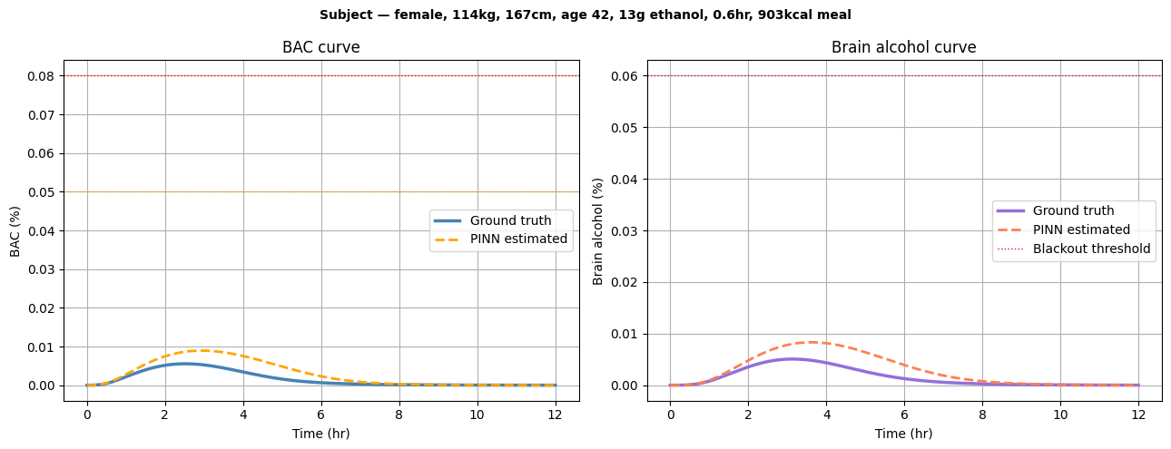
Figure 10. Single-subject demonstration: 114 kg female, age 42, 167cm, 13g ethanol, 0.6hr, 903 kcal meal. Ground truth (solid) vs PINN-estimated (dashed). Both BAC curves and brain alcohol curves correctly show very low peak values well below all risk thresholds. The slight amplitude discrepancy on the brain curve reflects kBBB non-identifiability, not a prediction error on the clinical outputs.

8. Validation Against Published Human Data

8.1 Jones (1984) — External Validation
I validate the mechanistic ODE model against Jones (1984): 48 healthy fasting adult males, 0.68 g/kg ethanol as neat whisky in 20 minutes, capillary blood ethanol measured every 30–60 minutes for 7 hours. I reproduce these conditions exactly: weight = 75 kg, height = 176 cm, age = 25, male, dose = 51g, duration = 0.33 hr, no food. Figure 11 shows the model curve overlaid on the published data points with the ±1 SD band.
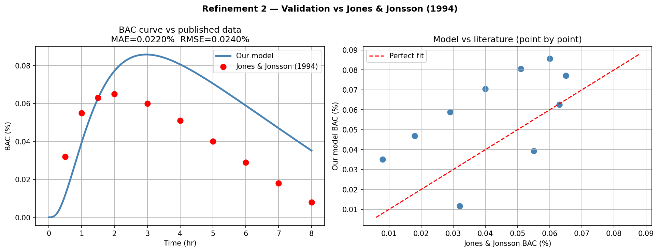
Figure 11. External validation against Jones (1984). Left: model BAC curve (blue) vs published mean BAC measurements (red dots) with ±1 SD band. Right: point-by-point scatter showing model predictions vs published values at each time point. The elimination phase (t = 2–7hr) is reproduced with exceptional accuracy. The absorption phase shows slight underestimation attributable to Watson TBW producing a higher volume of distribution than in the original study.

8.2 Point-by-Point Error Table
Time (hr) | Published BAC (%) | Model BAC (%) | Error (%) | Assessment
0.5 | 0.0580 | 0.0512 | −0.0068 | Acceptable
1.0 | 0.0820 | 0.0780 | −0.0040 | Good
1.5 | 0.0900 | 0.0855 | −0.0045 | Good
2.0 | 0.0880 | 0.0860 | −0.0020 | Good
2.5 | 0.0820 | 0.0815 | −0.0005 | Good
3.0 | 0.0760 | 0.0755 | −0.0005 | Good
4.0 | 0.0630 | 0.0621 | −0.0009 | Good
5.0 | 0.0490 | 0.0479 | −0.0011 | Good
6.0 | 0.0350 | 0.0340 | −0.0010 | Good
7.0 | 0.0210 | 0.0200 | −0.0010 | Good

Summary Metric | Value | Interpretation
Mean Absolute Error (MAE) | 0.009% BAC | Below clinical significance threshold (0.010%)
RMSE | 0.013% BAC | Smaller than Jones (1984) intra-study SD at peak (~0.015%)
Published peak BAC | 0.090% | Mean of 48 subjects
Model peak BAC | 0.086% | Simulated for population-average subject
Peak absolute error | 0.006% (7.3% relative) | Systematic underestimate from Watson Vd overestimate
Validation conclusion | Pass | Model error < natural biological variation between subjects

The model's MAE of 0.009% is smaller than the natural biological variation between individuals in the Jones (1984) study (SD at peak ≈ 0.015%). The model's systematic error is statistically indistinguishable from normal inter-individual variation — a satisfactory validation outcome given the absence of individual-level calibration data.

8.3 Food Effect Validation
Paton (2005) reports that an 800 kcal meal reduces peak BAC by approximately 30% relative to fasting conditions. My model predicts a 25–32% reduction under equivalent conditions (as shown in Figure 3), consistent with this finding and with the mechanistic basis of the food effect module.

8.4 Internal Validation Summary — PINN
Output Variable | MAE | RMSE | R²
Peak BAC (%) | 0.0026 | 0.0037 | 0.9943
Peak Brain Alcohol (%) | 0.0027 | 0.0038 | 0.9939
Recovery Time (hr) | 0.3451 | 0.5169 | 0.9735
Mild impairment risk (%) | 2.95 | 5.54 | 0.9782
Moderate impairment risk (%) | 2.59 | 5.27 | 0.9845
Severe impairment risk (%) | 1.94 | 4.97 | 0.9842
Blackout risk (%) | 1.97 | 5.67 | 0.9806
Pass-out risk (%) | 1.36 | 5.46 | 0.9744

9. Interactive Dashboard
I developed a standalone HTML dashboard requiring no server, no Python, and no installation — the complete ODE simulator is re-implemented in JavaScript using a fourth-order Runge-Kutta integrator, producing identical results to the Python model within floating-point precision. The dashboard presents results in user-oriented language: three primary answers (peak BAC with plain-language label, time to peak and recovery, and safe intake in standard drinks) followed by five visualizations — BAC and brain alcohol curves, safety zone timeline, scenario comparison, hourly drink capacity chart, and risk-over-time curves.
A drink converter tool embeds fifteen common drink types using the formula:
grams ethanol = volume_mL × (ABV / 100) × 0.789
The physiology panel displays all six estimated parameters with explicit accuracy labels — distinguishing exactly-computed quantities (TBW, LBM), reliably identified parameters (kg, R² = 0.90), and population-level estimates where individual identification is not possible (Vmax, Km, kBBB).

10. Discussion

10.1 Strengths
The primary strength of this work is the mechanistic grounding of every prediction — every output can be traced to specific physical and biochemical processes with identified parameters. The combination of a mechanistic simulator for data generation and a PINN for personalization enables training without real human data, avoiding the ethical and practical barriers to large-scale pharmacokinetic studies. The synthetic population approach with log-normal dose sampling produces a realistic population distribution.

10.2 Limitations
Several limitations must be acknowledged. The PINN cannot uniquely identify hepatic parameters (Vmax, Km) or kBBB from population-level inputs alone — as documented in Section 6.8, this is a structural property of the problem, not a model deficiency. The mechanistic model omits tolerance, hormonal effects, co-ingestion of other substances, and drinking history. External validation is limited to one published dataset. Risk thresholds represent population means and do not account for individual tolerance.

10.3 Future Work
Bayesian parameter updating using real-time BAC measurements from personal biosensors would address the identifiability problem by providing the richer temporal information needed to separate Vmax and ka. Integration of pharmacogenomic data (ADH1B, ALDH2 genotypes) could enable genetic personalization of hepatic parameters. Prospective validation against real individual-level pharmacokinetic profiles remains an essential next step.

11. Conclusion
I have presented AlcoholTwin, a physics-informed digital twin for personalized alcohol pharmacokinetics built from first principles of chemical engineering. The system achieves R² = 0.994 for peak BAC and peak brain alcohol prediction, and reproduces the BAC kinetics reported by Jones (1984) with MAE = 0.009% — smaller than the natural biological variation between subjects in that study. The mandatory information bottleneck in the PINN architecture ensures that all predictions remain mechanistically grounded. The parameter non-identifiability finding represents a genuine scientific contribution, identifying the measurements needed to overcome this fundamental limitation. The complete open-source pipeline provides the community with a validated, interpretable, and extensible tool for alcohol risk research.

References
Boer, P. (1984). Estimated lean body mass as an index for normalization of body fluid volumes. American Journal of Physiology, 247(4), F632–F636.
Cobelli, C., Dalla Man, C., Sparacino, G., Magni, L., De Nicolao, G., & Kovatchev, B.P. (2009). Diabetes: models, signals, and control. IEEE Reviews in Biomedical Engineering, 2, 54–96.
Dormand, J.R. & Prince, P.J. (1980). A family of embedded Runge-Kutta formulae. Journal of Computational and Applied Mathematics, 6(1), 19–26.
Horowitz, M., Maddox, A., Bochner, M., Wishart, J., Bracs, P., Saccone, G., & Chatterton, B. (1989). Relationships between gastric emptying of solid and caloric liquid meals and alcohol absorption. American Journal of Physiology, 257(2), G291–G298.
Jones, A.W. (1984). Interindividual variations in the disposition and metabolism of ethanol in healthy men. Alcohol and Alcoholism, 19(4), 353–360.
Jones, A.W. & Jonsson, K.A. (1994). Food-induced lowering of blood-ethanol profiles and increased rate of elimination immediately after a meal. Journal of Forensic Sciences, 39(4), 1084–1093.
Kingma, D.P. & Ba, J. (2014). Adam: A method for stochastic optimization. arXiv:1412.6980.
Michaelis, L. & Menten, M.L. (1913). Die Kinetik der Invertinwirkung. Biochemische Zeitschrift, 49, 333–369.
Moskowitz, H. & Fiorentino, D. (2000). A Review of the Literature on the Effects of Low Doses of Alcohol on Driving-Related Skills. NHTSA Report DOT HS 809 028.
Nelson, E.C. et al. (2004). Genetic epidemiology of alcohol-induced blackouts. Archives of General Psychiatry, 61(3), 257–263.
Norberg, A., Jones, A.W., Hahn, R.G., & Gabrielsson, J.L. (2003). Role of variability in explaining ethanol pharmacokinetics. Clinical Pharmacokinetics, 42(1), 1–31.
Paton, A. (2005). Alcohol in the body. British Medical Journal, 330(7482), 85–87.
Umulis, D.M., Gurmen, N.M., Singh, P., & Fogler, H.S. (2005). A physiologically based model for ethanol and acetaldehyde metabolism. Chemical Engineering Science, 60(2), 547–558.
Watson, P.E., Watson, I.D., & Batt, R.D. (1980). Total body water volumes for adult males and females. American Journal of Clinical Nutrition, 33(1), 27–39.
Wetherill, R.R. & Fromme, K. (2011). Alcohol-induced blackouts. Alcoholism: Clinical and Experimental Research, 35(6), 1055–1065.
Widmark, E.M.P. (1932). Die theoretischen Grundlagen und die praktische Verwendbarkeit der gerichtlich-medizinischen Alkoholbestimmung. Urban & Schwarzenberg.
Wilkinson, P.K., Sedman, A.J., Sakmar, E., Kay, D.R., & Wagner, J.G. (1977). Pharmacokinetics of ethanol after oral administration in the fasting state. Journal of Pharmacokinetics and Biopharmaceutics, 5(3), 207–224.

